**Fabric and window treatments**

**IDEC1045**

**Drapery hardware and Measuring and calculating soft window treatments**

1. Replace the highlighted areas above.
2. Fill in the cells on the right in the table below.

## Week at a Glance

|  |  |
| --- | --- |
| **Week at a Glance** | |
| This week’s course learning outcomes (number and text) | **CLO04:** Outline current fabric trends including pattern, texture and styles as well as uses and benefits of linings to create quality window treatments for various uses.  **CLO05:** Calculate both hard and soft treatments to custom order from a manufacturer or seamstress based on appropriate measurements to complete a window treatment order for a client NOTE: this was not in the first matrix but I corrected it with Mihaela |
| This week’s unit learning outcomes (number and text) | **Unit 5:**  5.1 Recognize various functional and decorative hardware materials used in today’s drapery treatments including wood and metal, their styles and uses  5.2 Explain fabrication uses of a Velcro board  5.3 Outline basic window treatment installation of rods.  **Unit 6:**  6.1 Calculate fabric requirements for stationary side panels, operating drapery and sheers  6.3 Identify wall spaces needed for fullness and stack back requirements and standards |
|  | |
| This week’s problem | This week’s problem is to start to learn how to measure windows correctly and how to calculate the amount of fabric for stationary window treatments, sheers and operating treatments including stack back requirements, lengths and fullness. This is a vital requirement in order to purchase the correct amount of fabric, lining and supplies to create a window treatment and order from a seamstress. |
| How does this week’s problem fit into the course so far? | This is a continuation of the process of creating a window treatment that all decorators need to know and builds on the previous lesson information. |
| List of topics and subtopics that will be covered to address this week’s problem | **Getting down to business…**  **How to measure a window:** tools needed, interior window measure (not including trim), exterior measure (including trim)  **Drapery hardware**: rods, rings, styles and sizing of hardware  **Calculate stationary treatments**: window size, fabric amount, lining requirements and amounts, pattern repeat  **Calculate operating treatments** window size, fabric amount, lining requirements and amounts, pattern repeat, stack back  **Calculate sheer treatments**: window size, fabric amount, stack back |
| If this is a hybrid course, what topics and activities will be covered in-class to support the online content? |  |
| How does problem fit into the remaining weeks of the course? | This week is required to complete the assignments, exam and final project that require the information from this week for evaluation. This week expands the student’s knowledge to calculate the amount of fabric needed for drapery treatments |
|  | |
| Graded Assessment? | Yes. Fill out the Evaluation section below.  No. |

## Introduction

|  |  |  |
| --- | --- | --- |
| **Introduction to Week** | | |
| Introduction | Description of content for this week:   * Explain what the user will learn * Describe the problem the user will be able to solve by the end of week * Answer the question “What’s in it for me (the learner)?”   This week we will be getting into more detail about planning window treatments. We will look at the various drapery hardware on the market and how to use them and also learn to measure a window accurately. The second part of this week will be learning to calculate stationary and functional drapery treatments as well as sheers on a window. This is important information that all decorators need to learn to be able to order fabric and give a work order to a manufacturer or seamstress to complete a correct treatment. You do not need to know how to sew but you do need to know how much material you need, lining requirements and hardware to have a wonderful treatment. | |
| Learning Outcomes | Write out the week’s unit learning outcomes here (number and text).  Unit 5:  5.1 Recognize various functional and decorative hardware materials used in today’s drapery treatments including wood and metal, their styles and uses  5.2 Explain fabrication uses of a Velcro board  5.3 Outline basic window treatment installation of rods.  Unit 6:  6.1 Calculate fabric requirements for stationary side panels, operating drapery and sheers  6.3 Identify wall spaces needed for fullness and stack back requirements and standards | |
| Other relevant announcements/ reminders | Insert notes on assignments and/or anything out of the ordinary.  Note: You can also add an image here for a front cover page look and feel.  Istock id: 184877177  C:\Users\Linda\Downloads\184877177.jpg |

***************** Beginning of instructional content ************************

# Getting down to business…

Now that you have been introduced to fabrics let’s get down to the business of creating a window treatment from the ground up. We will go over how to properly measure a window, explain drapery hardware and learn to measure stationary, operating and sheer treatments as well as calculate the amount of face fabric and lining required.

**Follow along as we go and when measurements are being explained, you will learn better if you do the activity with the lesson. We will have some practice questions also for you to do at the end that will give you practice to do this week’s assignment.**

I am sometimes asked “Why do I have to know this information? I am the decorator and not making the treatment”. My answer is that it is important to know how to measure properly for all windows as the seamstress will sew the treatment according to the decorator’s specifications and the installer will hang according to the same specifications.

It is up to the decorator to design the style of the treatment that is suitable for the window shape, size and function. It is also up to the decorator to select the appropriate fabric that will suit all needs and to order the correct quantity. This means that the decorator has the most responsibility and therefore needs to have, record and keep accurate records to make sure the treatment is done properly.

Measuring a window:

One of the most important things to learn when dealing with window treatments is to correctly learn how to measure a window. This may sound basic but it is so important to be accurate as mistakes can be very costly to the decorator.

Even if you have 3 identical looking windows in a room, there may be slight different measures for each and so we need to make sure that each window is measured correctly.

Tools needed to measure:

* A good quality retractable, sturdy 25 foot metal tape measure (never use a cloth tape measure or yard stick). Learn how to read a tape measure (1/2”, ¼”, 1/8” etc.)
* A ladder preferably with a wide step for safety. (I use a 3 step ladder with a kind of landing to stand of for better balance). If you are to measure 2 story windows, get an installer to do this for you. The cost is worth it.

Istock id: 622520574

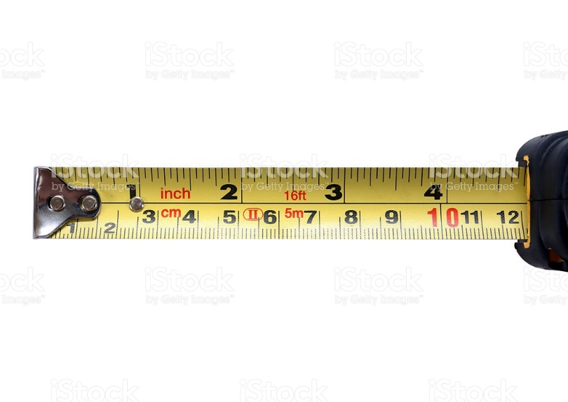

* Graph paper, ruler and pencil to draw and mark your measurements
* Calculator
* A digital tape recorder to record your measurements. I use this tool all the time as a handy backup to what I write.
* A camera to take photos of the window, wall etc. (a picture is worth a thousand words)

**Steps to measuring:**

* Draw a quick sketch of each window and mark position on wall. The initial drawing does not have to be to scale and can draw exact ½” scale when planning at home.
* Note how the window will open (in, out, up/down etc.)
* Measure all surrounding wall areas between trim and ceiling, floor, walls to know the space allowed around the window
* Measure the depth of the window from the wall (is window recessed or flush?)
* Be sure to record all measures in the correct location on your drawing which becomes your working copy.
* Always measure and order by **width first** in inches and then the **height second**. Measure twice for accuracy.
* Never measure the existing drape or window treatment as you will not get an accurate enough measure.

**Inside window measurement:**

Inside window measurements do not include the trim but the exact distance of the window and frame without the trim or inside the trim frame of the window.

* Measure inside width at top, middle and bottom of window and record on your drawing
* Measure inside height at left, middle and right of window and record on your drawing
* When ordering you would use the lowest width measure to order and the longest length measure to order

Istock id: 91719540 I added the red arrows to show the distance

Inside measure is the exact distance of the window and frame but not including the trim.

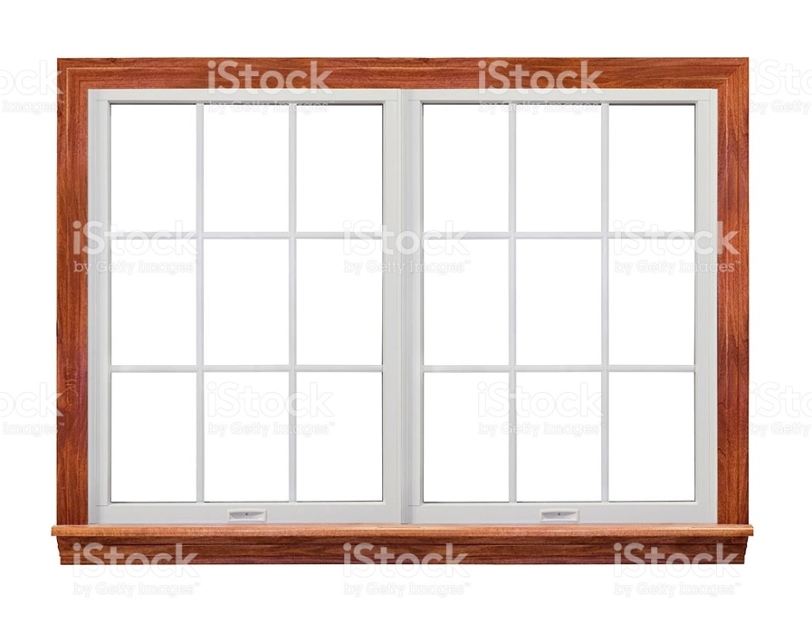

**Outside window measurement:**

An outside window measurements include the trim size and so you would measure from the outside of one side the window for this kind of measure.

* Measure the outside width at the top, middle and bottom of window and record on your drawing
* Measure the outside height at left, middle and right of window and record on your drawing
* When ordering you would use the widest measure and the longest measure to order

A window treatment should hang at least four inches above the top of the window trim and 4 inches on each side of the window width.

Istock id: 91719540 I added the red arrows to show the distance

Outside measure is the exact distance of the window, frame and including the trim



This website shows how to measure a window

[**http://www.thebauhaus.ca/how_to_measure_windows.htm**](http://www.thebauhaus.ca/how_to_measure_windows.htm)

Drapery hardware:

Istock id: 617587432



Drapery hardware is a really fun and exciting part of a treatment. While some hardware is hidden much of it today is visible and adds to the design and overall look and appeal of the treatment. Hardware varies greatly in style and visibility and below are some of the kinds of hardware on the market to select from.

This website is for Canadian Drapery Hardware which is only one of the hardware companies used in the drapery industry. The website will show you various kinds of drapery hardware. <https://cdhltd.com/>

### **Functional rods:**

Functional rods are often not visible on the treatment. They are rather inexpensive and simple in design to allow a treatment to hang or operate with ease but are not part of the overall style or offer any decorative touch to the drape. These kinds of rods rarely change over the decades as they do not follow design trends.

The most common is called an “**I beam”**. This I beam is a simple rod that has small rings slid onto it to allow to hook a treatment on to open and close. This is a good rod to use if the drape is mostly closed or hidden under a valance or cornice. It is versatile as it can be hung on a wall or ceiling and is sold by the foot. Most installers carry I beam that they can cut to the appropriate length when installing. It is also useful if you have a treatment that needs a curve as it can be bent to go around corners or curves in the window. An I beam usually is hung about 1 inch from the ceiling so the treatment has room to slide without touching the ceiling.

Could not find a picture of an I beam

A **“pocket rod”** is found in a lot of stores for ready-made drapery or valances that is a flat or small round kind of metal rod, usually white with small brackets that hold it to the wall. Some are tension rods used between window trim similar to a shower curtain. The pocket rod is very inexpensive, comes in expandable sizes for simple and light treatments with a pocket rod pleat style that can be found in many stores like hardware and general merchandise stores.

Could not find a picture of a standard metal pocket rod

A “**Velcro board”** is not an actual rod but a piece of wood (like a 2’x4’ or larger) that is covered in either lining or fabric matching the treatment used to hand some valance styles. It has Velcro attached to the edges that allow a swag or flat treatment like a roman valance or shade to be attached. They can be made in any size and can be placed on a ceiling or wall using “L” brackets. This is a great application that allows the treatment to be easily removed for cleaning. Some heavy swag treatments may be stapled to a board when they would be too heavy for Velcro.

By Linda Guthro

These photos show a small example of a Velcro board.

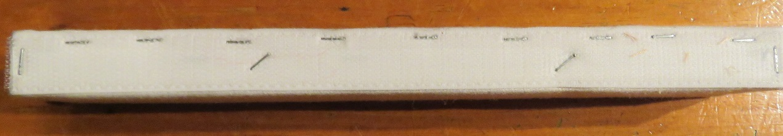

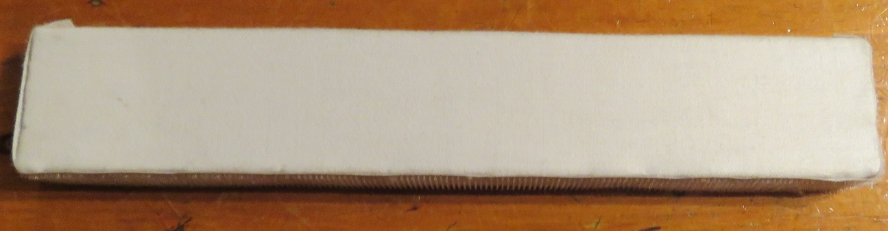

Velcro boards can also be used to hang multiple treatments such as a tailored valance, side panels and sheers by attaching 3 I beam rods to the Velcro board

Can we redraw this photo to cover copyright?

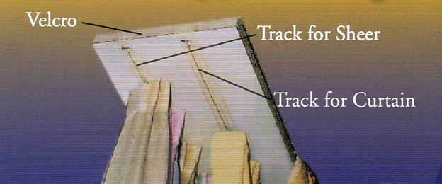

### Decorative rods:

Decorative rods can range from simple wood poles and brackets to elaborate metals of all colours. The decorative rod is visible and an important element to the end result and impression of a window treatment. This kind of hardware shows the drape suspended below a visible rod and used for many styles of drapery and valances. Decorative rods add texture and colour and come in a variety of wood and metal finishes in diameters from 1-3 inches. Longer lengths are held together by a splice and can be cut to the correct size upon installation. Solid rods rather than expandable ones are recommended to make sure the rod is the same diameter across the entire length for a more finished look. The wider the window the larger the diameter of the rod should be. Large rooms or those with a higher ceiling should always use a large rod to match the proportions of the room. Since the rod is decorative and part of the window treatment design, it is important to have it large enough to show well in a room. Usually the decorative rods are sold separate so one can select the bracket (to hang the rod), ring (to attach the treatment) and finial (the decorative end piece on the rod) of choice. They manually open by pulling the drape or using a small rod hanging down from the rod.

Istock id: 155357066

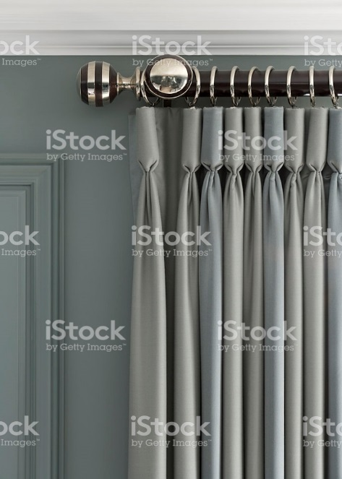

Wood decorative rods:

The most popular diameter or a wood rod is 2” and would be used on windows larger than a 5 foot span. There are many colours of wood tone and even unfinished ones that can be painted in any colour. Styles available from plain to very ornate to suit every décor. Wooden rods often compliment the other woods used in the room.

Istock id: 173613961

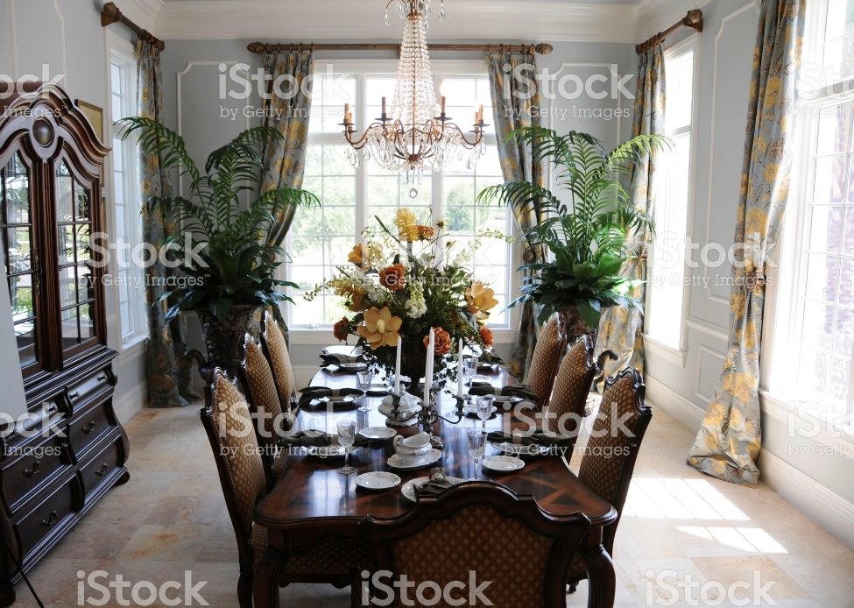

Metal decorative rods:

Metal rods are the most popular hardware and come in colours from black wrought iron to white, bronze, silver and gold. Some even come with crystal finials to add some bling. There are new styles coming on the market all the time and can be a very exciting and fun addition to a drapery treatment.

Istock id: 173635507

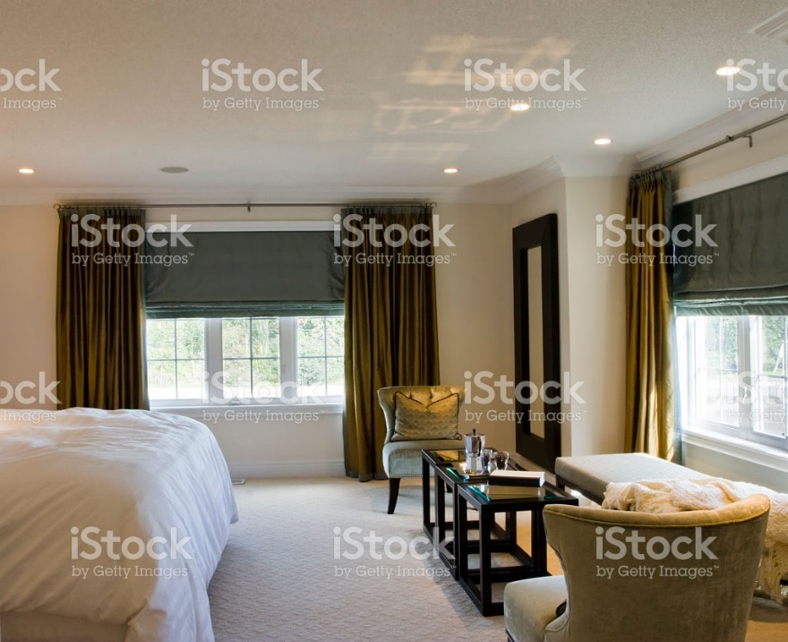

Knobs:

Knobs are another kind of decorative treatment used for stationary treatments only. They are like a door knob that are attached to the wall in place of a rod and rings. They are not as common but can offer a dramatic effect on certain window styles.

Istock id: 155099229

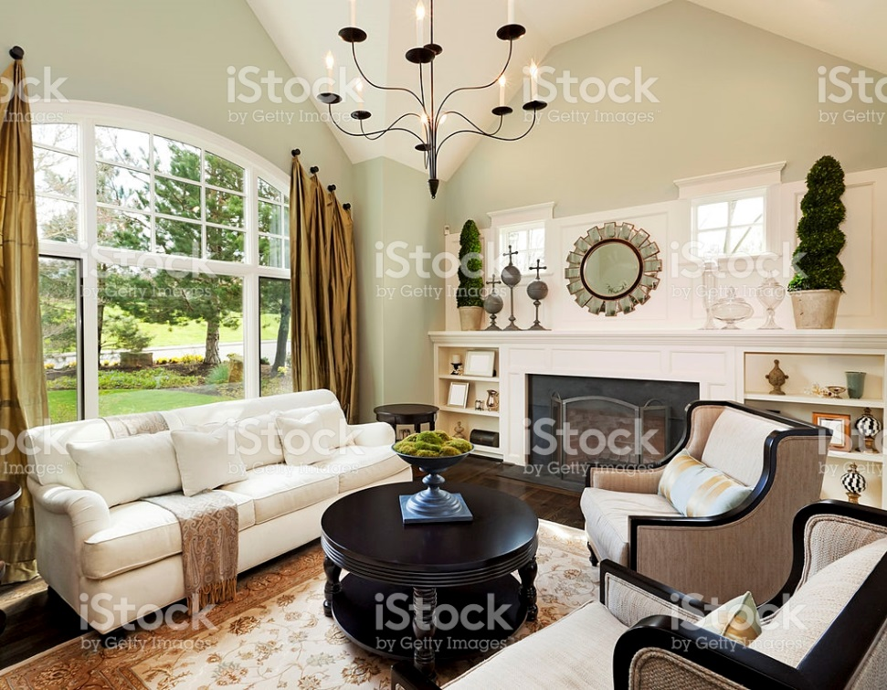

Traverse rod:

A traverse rod is a decorative rod that has cords attached that operate the treatment to open and close. For several years they were not available, however now they are becoming popular again. They come in many colours and styles to suit today’s décor. They can be functional (hidden) or decorative and can be made to open one way or open both ways from the middle of the rod.

Could not find a picture of a traverse rod

## **Calculating window treatments:**

When calculating the amount of fabric needed for any window treatment you first need to draw in pencil on graph paper a ½”scale drawing of the window with accurate measurements. This working copy should be kept for future reference and will help you to calculate the amount of fabric needed more accurately. You can also show the dimensions of the treatment you are planning to make sure it will look as you want it to. This is a very important step.

Selecting the fabric and appropriate lining is a main step and then you must make some other decisions.

For all treatments you must decide what kind of hardware you will use (colour, style), how long the treatment will be and how high it will hang on the wall.

In general you would measure the treatment from the top of the rod to the length you want it (1/2” from the floor for full length). The minimum height above a window trim to hang a treatment is 4 inches and anywhere above that to the full ceiling height. Most decorators prefer to hang high at ½ way from the top of the trim to right up to the ceiling.

If you are covering the window only you need to add 4 inches on each side of the window trim to fully cover the window properly.

It is always recommended that you hang a treatment to the floor if it is in the budget rather than ending at the bottom of a window for a more professional look. If you have baseboard heating you must end the treatment just above the heater for fire safety code. You cannot have a treatment cover baseboard heating.

Some header styles need some consideration to add to lengths.

**Pocket gather**: add 1-2 inches depending on the size of the rod to the finished length to allow for “take up” when gathering on the rod. If you want a ruffle above the rod add another 1-2 inches for the ruffle above the rod.

**Grommet:**  Grommets are rings that are placed 1” down from the top of the finished edge to create the header. This means when you are calculating the finished length you need to add 1” for the fabric above the rod to your total length.

**Decorative rods**: Decorative rods use rings to hold the drapery and come in various sizes as well for the different rod sizes.

If you are using a decorative rod with rings, you need to measure the diameter of the ring and deduct that from the length of your drape. The fabric treatment will hang from the bottom of the ring and not from the rod and so you need to deduct the diameter of the ring from the overall length to determine how long the drape should be. For example: if you have a 2” diameter ring on a rod, then the drape would hang 2” below the top of the rod.

If you are hanging right up to the ceiling with a decorative rod, this means that the wall bracket holding the rod will be right up at the ceiling making the rod about 1” from the ceiling. You do need to make sure it leaves enough room to fit the finial as well as some finials can be very large and need a bit more room.

**Specialty shapes and applications**: (2 story, diagonal or arch windows) need special measuring procedures. Sometimes you need to make a template of the window shape so when in doubt have a professional installer do a check measure for you for trouble-free installation. I always get an installer to measure these for me.

**General imperial measurements**: 1’ (foot) = 12” (inches)

1 yard = 36”

8’ ceiling = 96”

9’ ceiling = 108”

10’ ceiling = 120”

**Specify type**:

**A Panel** is a single drape that can be stationary or operate from one side only.

**A Pair** is 2 panels that can be stationary or open from the middle to each side

**Fullness** is how much the flat piece of fabric is gathered to make pleats. Fullness makes for a luxury look in treatments and it is important to use the correct fullness to not look too skimpy and cheap. Different styles can require different fullness.

**Tab/tie top** is 1 ½ to 2x fullness

**Pocket rod** is 1 ½ to 2x fullness (depending on thickness of fabric)

**Grommet** is 2 to 2 ½ x fullness

**Pleated** is 2 ½ x fullness

**Sheers or very thin fabric** is 3x fullness

How to calculate Stationary treatments:

A stationary treatment is one that is decorative and does not move. It is a single or pair of panels at the sides of a window and often covering more wall than window. The amount of fabric for a stationary panel should be proportionate to the window width. The wider the window the wider the side panels should be. When hanging a pleated panel, allow 1-2” of fabric width to let the fabric relax without being stretched on a rod.

For all our pleated measurements we will use a 54” (standard width of fabric from the bolt) for our calculations. This 54” width is the width of the fabric from one salvage edge to the other when lying flat. Check the fabric you are using for the actual fabric width as they can vary.

**1 width** is a single width panel needs to be pleated to create fullness at 2 ½ x fullness which means that we have to scrunch up that single width to create pleats. To do this you need to fold in the salvage edges to create a neat hem and not see the salvage. This is done by folding in the salvage sides 3” on each side of the fabric or 6” in total.

Therefore a 54” fabric – 6” to finish the salvage edges = 48” of finished fabric divided by 2 ½ for the fullness amount = 19.2” of pleated fabric. Since we need to allow the fabric to “relax” while hanging you would get a panel that is 18” in width to hang.

If you need a fuller panel for a wider window you could use larger widths:

**1 ½ widths** = one 54” piece of fabric and ½ of that width again which his 27” sewn together. This = 81” of fabric – 6” salvage edge = 75”, divide by 2 ½ fullness = 30” taunt or 29” relaxed. 1 ½ widths requires 3x54” pieces of fabric called cuts, to make 1 ½ for each side.

By Linda Guthro

Notice that there are 3 cuts of fabric and one is cut in ½ and will be attached to the full cut to make 1 ½ panel width for each side of a window.

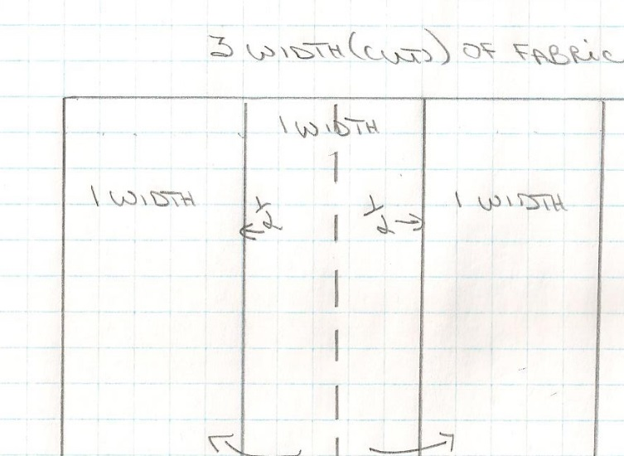

**2x width** = two 54” pieces of fabric sewn together = 108” – 6” selvage = 102” divided by 2 ½ X fullness = 40.8” taunt fabric pleated or about 38- 39” relaxed. 2x 54” of fabric are needed for double width making the total pieces of 54” fabric x4 for both panels.

**Calculate a single pair of stationary side panels:**

**Part 1 Dimensions:**

* Ceiling height 8’
* Window size 5’ (60)” wide x 4’ (48”) high
* 18” from ceiling to window
* Trim added to outside of window = 6”
* This is a plain fabric that is 54” wide, with pinch pleats and a standard lining.
* Rod is a decorative rod with 2” rings.
* Hang treatment 4” above the trim
* Draw the window to ½”scale on graph paper for your working copy

By Linda Guthro

This is a working copy showing the window measurements. Write anything you need to remember on this page to help you calculate. No one sees this page but you.

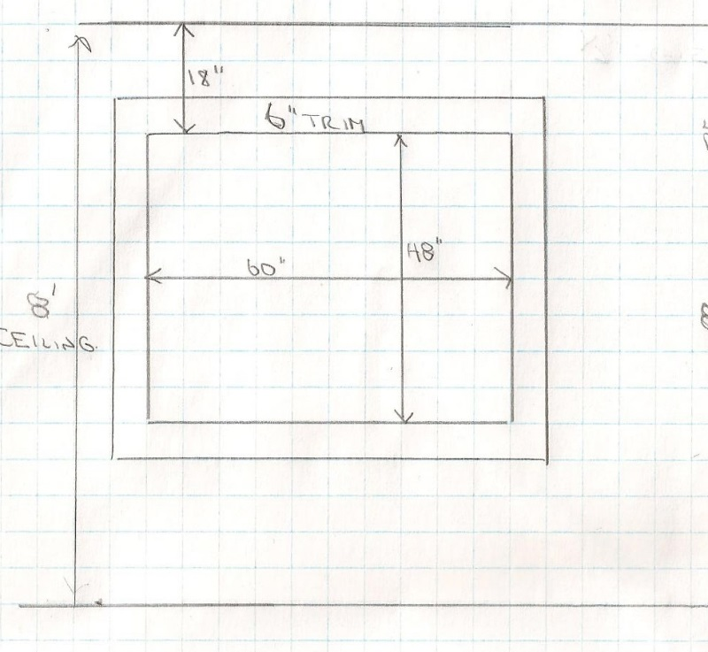

**Part 2 Calculations**: Finished width and length of fabric. Rod width

Width:

* This is 1 panel on each side of the window so only 1 piece (1 cut) of fabric is needed
* 54” fabric – 6” to finish the salvage edges = 48” divided by 2.5 fullness for pleated style = 19.2” taunt or 18” relaxed on the rod. This will give 18” width of panel on each side of the window
* Rod width = 5’ (60”) for window + 12” trim (6” on each side of window) + 8” (4” past the trim on each side) = 60”+ 12”+ 8”= 80” finished rod width.
* Finials will be added to the ends

Length:

* Measure from floor to top of trim = 78”
* Add 4” above the trim = 78”+ 4” = 82’= where the rod is hung
* Rings are 2” diameter so must deduct 2” from the drape length (that hangs down from the rod) = 82-2” = 80”
* Want ½ “ from the floor for full length = 79 ½” finished length

By Linda Guthro

This drawing shows where the treatment goes on the window. It helps you see the proportions and visualize better.

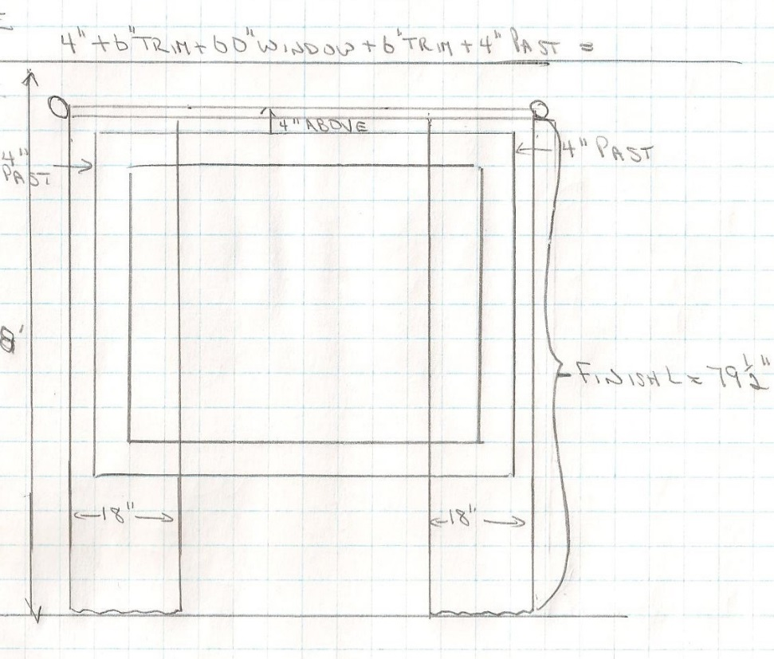

**Part 3 Order/purchase dimensions**: Fabric and lining needed to order

* So now the finished length of fabric is calculated but this is not the amount to order/purchase. When ordering the fabric it is necessary to add the fabric needed to make the hem and header (pleat style)
* The finished width is already calculated and we know that we are using 1 width (1 cut) of 54” fabric only.
* The finished length is 79 ½” length and we need to determine how much fabric is needed for the hem and header (pleat).
* **For all pleated drapery always add 16” for hem and header**.
* So you need to add 79 ½” + 16” = 95.5” minimum. This is the order length needed to make the panel.
* You have 2 panels (one on each side of the window) so you need to multiply this number by 2 for the total amount of fabric to order. 95.5 X 2= 191”.
* When ordering you do so by the yard. There are 36” in a yard so you divide 191 by 36 = 5.3 yards.
* **Always round up** to allow for errors or flaws in fabric so you would order 5 ½ to 6 yards of fabric to get the 2 panels made. ( I usually order to the next ½ yard to be safe)
* You will always order by the yard (not inches). In some cases you can also order by the meter which is = to about 39”.
* **How much to round up?** To be safe always round up to the next ¼ yard or more. A bit more fabric will allow for errors or flaws and it is better to have more fabric than less and have to order the entire thing again! Remember you need the same dye lot which is hard to get once you have ordered.
* Since the fabric has no pattern you would order the same amount of lining
* If you had a pattern repeat, you would add this to the length of each cut of fabric to allow matching of pattern.
* You would adapt the measurements according to the height you want to hang the treatment and how far off the window you want the treatment to be.

**Interesting note**: A quick reminder about fabric amounts is that if you are making a simple single width pair of drapery, it will always require at least 6 yards of fabric (more if hung higher). If your numbers come to something less than that you will know you missed something!

**Things to remember for Stationary panels:**

Part 1: Measurements of window, trim, walls, ceiling height, kind of treatment, drawing to ½” scale

Part 2: Finished width (# of cuts, salvage, fullness), finished length (how high above window, how long), rod length (window, trim and past window distance)

Part 3: Add hem and header to finished length, pattern repeat if any, round up to nearest ¼ - ½ yard. This is the amount you need to order to get your desired finished treatment.

**Practice this window example and compare it to the answer.**

**#1 Practice Stationary side panels:**

Determine the amount of fabric and lining required as well as length of the decorative rod for the following…

* Window 55” wide x 66” long + add 3” trim to outside of this window
* 9’ ceiling
* Ceiling to window = 20” glass
* Pair of stationary side panels with 27” pattern repeat
* Pleated @ 2 ½ fullness
* Each panel side to cover 12” of wall past the trim on each side
* Hang ceiling to floor on an I beam
* What is yardage of fabric and lining
* How wide should the rod be?

**#1 Practice stationary side panels answer:** Can we reveal this after they try the question?

**Part 1:**

* Draw the window to ½” scale on graph paper to include measurements

**Part 2:**

**Determine Width:**

* Single panel @ 54” fabric width = 54” – 6” selvage = 48” divide by 2.5 fullness = 19.2” or 18” relaxed

**Determine length:**

* 9’ ceiling = 108” – ½” from floor -1” from ceiling = 106.5” finished length
* + pattern repeat of 27” + 16” hem and header = 149.5” order/purchase length per panel

**Part 3:**

* Need 2 single panels so 149.5” x 2 = 299” divide by 36 (# of inches in a yard) = 8.3 yards, round up to 8.5 yards minimum to order

**Rod needed:**

* If you want 12” of treatment on the wall and window is 55” wide…
* Panel = 18”– 12” on wall – 3” trim = 3” over window
* Window glass = 55” – 3” – 3” (over window) = 49” exposed glass + 18” + 18” (width of panels)= 85” rod = 7.08’ rod or 7’ rod
* You can round down because rod size is less than .1 over the size. With a stationary treatment you can place the panels anywhere you want on the wall so you are able to round down

By Linda Guthro

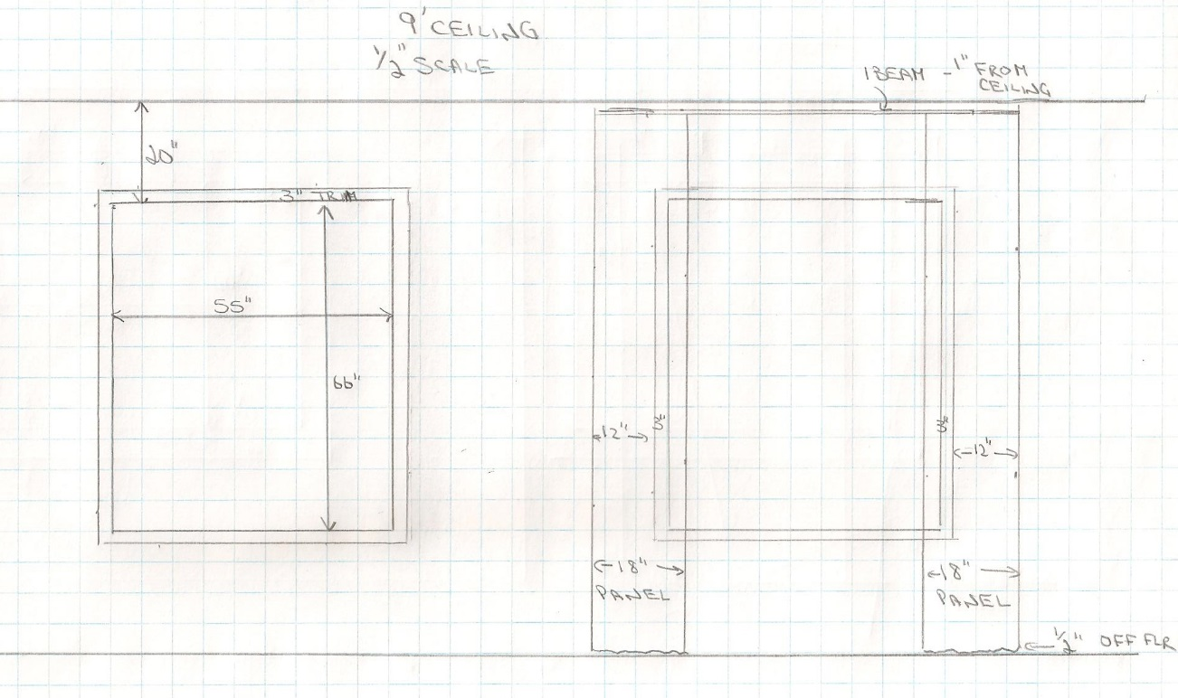

How to calculate Operating treatments

Operating treatments are panels that open and close over a window also known as functioning drapery. They can be hung on a decorative rod, traverse rod or I beam. An “I” beam is not attractive to see so a valance would be needed to cover the “I” beam.

Functioning treatments are different from stationary and need other considerations.

**1. Stack-back**

Since they operate, a stack-back calculation is needed to allow the drape to open fully off the window. The stack-back is the amount of wall space needed to allow the drape to fully open. This stack back is 1/3 of the actual window size (1/2 of the stack back applied to each side of the window).

Can this photo be re-drawn to cover copyright? Window style can be plain and no script needed on drawing

This photo shows the dotted lines where the stack-back would be needed to open the treatment fully.

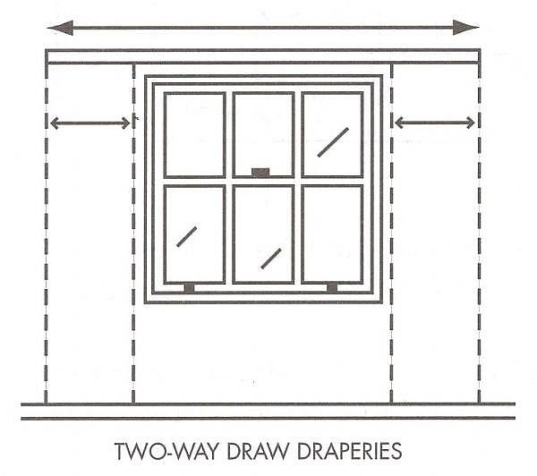

**2. Overlap allowance**

When drapery open and close, there is an overlap allowance needed to let the fabric relax when meeting in the middle. A 4” allowance will not show a gap when the fabric relaxes and is important to include in calculations. This allowance is added to the width of fabric when calculating the flat fabric.

**Calculate a pair of functioning drapery:**

**Part 1 Dimensions:**

* Ceiling height 8’
* Window size 5’ (60)” wide x 4’ (48”) high
* Trim added to outside of window = 6”
* This is a plain fabric that is 54” wide, with pinch pleats and a standard lining.
* Rod is a decorative rod with 2” rings.
* Hang treatment 4” above the trim
* Draw the window to ½” scale on graph paper for your working copy

By Linda Guthro

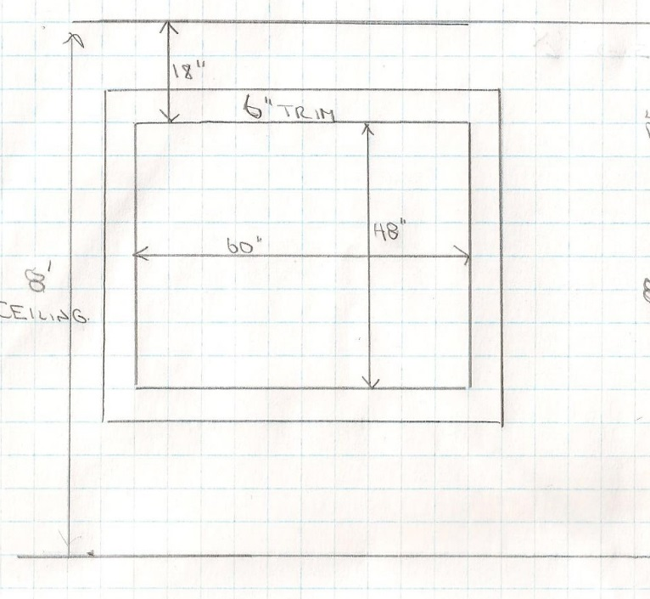

**Part 2 Calculations**: Finished width and length of fabric. Rod width

Width:

* Functioning (operating) treatments need more calculations. This is not difficult but it is important to write down ALL necessary calculations. I like to write it across the top of my drawing to make sure I include all numbers needed.
* This is an operating treatment so a stack-back in needed on each side of the window so the treatment can fully open off the window. Stack-back is 1/3 of the window width. Since the window is 5’ or 60” in width= 60 x.33 = 19.8” divided by 2= 9.9 or 10” needed on each side of the window. Add this calculation to the width of the window
* Overlap calculation needs to be added as 4” to the drawing
* When calculating the amount of fabric width needed you need to add all the measurements up across the window as follows in this example from left to right on the drawing
* 10” stack-back + 6” trim + 60” window + 4” overlap + 6” trim + 10” stack-back = 96” of area needs to be covered at 2.5 fullness to make the pleating. 96”x2.5 = 240” + 6 + 6 salvage edges = 252” of fabric width is required.
* 54” fabric being used. How many 54” pieces (cuts) of fabric are needed to cover?
* 252” divided by 54” of fabric for each cut = 4.6 cuts. This means that you need 4.6 pieces of 54” fabric to make the treatment that will open and close over the window.
* You cannot have part of a cut so you must round up to the next full number = 5 cuts needed.
* Rod width = is the amount of area needed which is calculated previously that showed how much area needs to be covered which is 96”- 4” overlap = 92” rod length.
* Finials will be added to the ends

Length:

* Measure from floor to top of trim = 78”
* Add 4” above the trim = 78”+ 4” = 82’= where the rod is hung
* Rings are 2” diameter so must deduct 2” from the drape length (that hangs down from the rod) = 82-2” = 80”
* Want ½ “ from the floor for full length = 79 ½” finished length

By Linda Guthro

The stack-back is showing the drape fully open and how much wall space is needed.

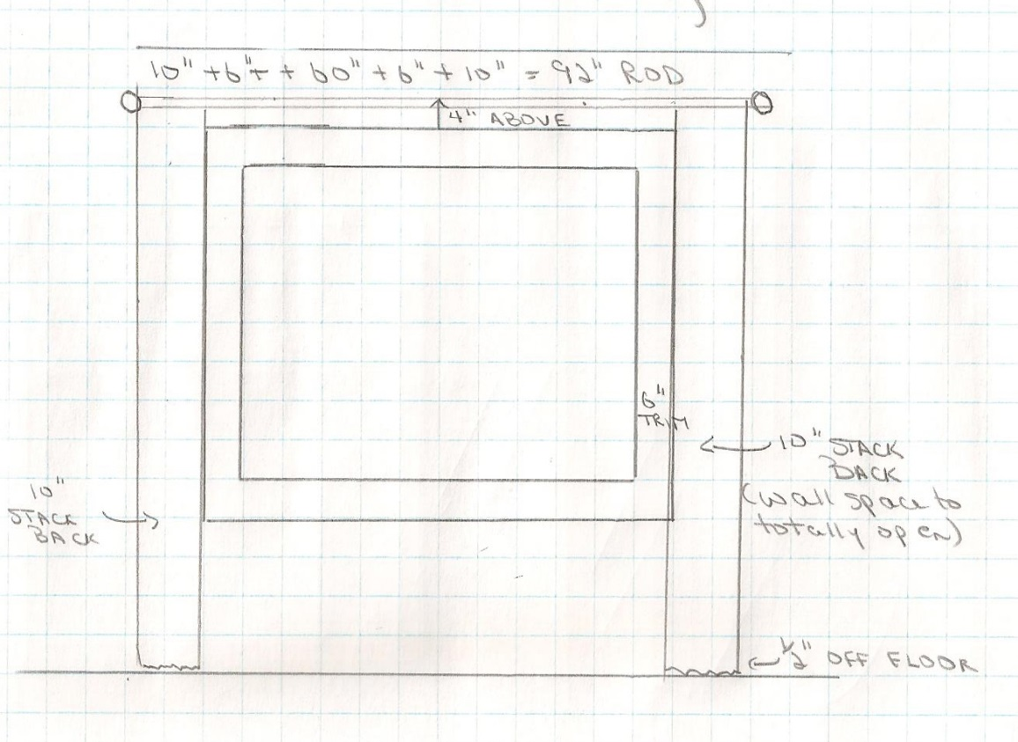

**Part 3 Order dimensions**: Fabric and lining needed to order

* So now the finished length of fabric is calculated but this is not the amount to order. When ordering the fabric it is necessary to add the fabric needed to make the hem and header (pleat style)
* The finished length is 79 ½” length and we need to determine how much fabric is needed for the hem and header (pleat).
* **For all pleated drapery always add 16” for hem and header**.
* So you need to add 79 ½” + 16” = 95.5” minimum. This is the order length needed to make the panel.
* The width is already calculated and we know that we need 5 cuts of 54” fabric.
* 5 cuts X 95.5 length per cut = 477.5”
* When ordering you do so by the yard. There are 36” in a yard so you divide 477.5 by 36 = 13.26 yards.
* **Always round up** to allow for errors or flaws in fabric so you would order 13 ½ yards minimum of fabric to make these operating drapes.
* You will always order by the yard (not inches). In some cases you can also order by the meter which is = to about 39”.
* **How much to round up?** To be safe always round up to the next ¼ yard or more. A bit more fabric will allow for errors or flaws and it is better to have more fabric than less and have to order the entire thing again! Remember you need the same dye lot.
* Since the fabric has no pattern you would order the same amount of lining
* If you had a pattern repeat, you would add this to the length of each cut of fabric to allow matching of pattern.
* You would adapt the measurements according to the height you want to hang the treatment and how far off the window you want the treatment to be.

**Things to remember for Operating/functional treatment:**

Part 1: Measurements of window, trim, walls, ceiling height, kind of treatment, drawing to ½’ scale

Part 2: Finished width (# of cuts, salvage, and fullness), finished length (how high above window, how long), rod length (window, trim and past window distance), overlap of 4” to not have gap between panels when closed together, stack-back if needed.

Part 3: Add hem and header to finished length, pattern repeat if any, round up to nearest ¼ - ½ yard. This is the amount you need to order to get your desired finished treatment.

**Practice this window example and compare it to the answer.**

* Window 72” wide, 55” long + 3” trim added to the window size
* Ceiling = 8’
* Space from glass to ceiling = 12”
* 1 pair of operating/functioning drapery that cover window only (no stack-back)
* Pleat style = Grommet at 2x fullness
* Hang full length (1/2” from floor) and 6” above the trim
* How many yards of fabric is needed for a plain fabric? Finished length and order/purchase yardage.
* How much lining is needed?
* Length of rod?

**Practice operating drape answer:** Can we reveal this after they try the question?

**Width for operating drapery:**

* **Add:** 4”past + 3” trim + 72 window + 4” overlap in middle to let treatment relax and not see gap + 3” trim + 4” past = 90”
* 90 x 2 fullness = 180 + 6 + 6 selvage (for a pair of panels) = 192 divide by 54” fabric width = 3.5 **\*\*\*cannot have part of a cut\*\*\*** so need 4 cuts

**Rod needed:**

* Add 4 past +3 trim + 72 + 3 trim + 4 past = 86” rod = 7.16 rod ***do not include overlap here ***

**Length:**

* 8’ ceiling = 96”. Space between glass and ceiling = 12” (add 3” trim around window) = 9” between trim and ceiling.
* -6” above trim = 3” from ceiling
* Treatment hangs 6” above the trim Therefore 96 “ ceiling height – 3” from ceiling = 93”
* 93 + 1” for grommet style over rod = 94”
* - ½” above floor = 94” – ½ from floor = 93.5” finished length
* + 16 hem and header = 109.5 = order/purchase length per cut
* # of cuts x order length 4x109.5 = 438” divide by 36” in yard = 12.16 yards
* Round up to 12 ¼ – 12 ½ yards to order/purchase

By Linda Guthro

The drawing shows the treatment closed and the overlap needed to remember.

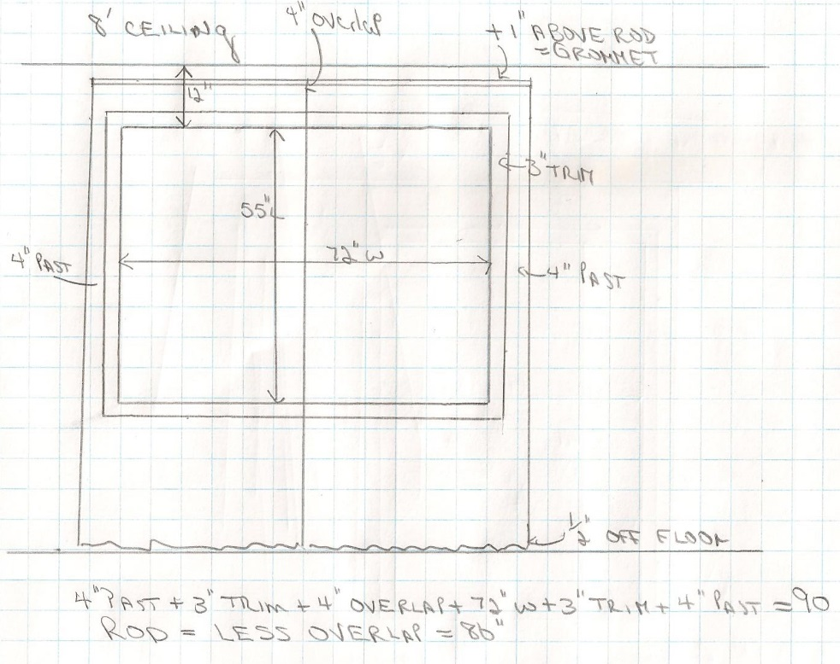

Calculate Sheer treatments:

Most sheers come in much wider widths than other materials. It is preferred to have sheers with no seams in each panel if possible and for that reason we try and railroad the fabric is we can as decorators. Usually sheers are always closed and so if that is the case you can make one panel that covers the window and is stationary. In other cases the client may want them to open and so you would make a pair of panels. Remember to calculate stack-back if you are doing this.

Sheers come in varying sizes of widths depending on the style. While most sheers that are plain or pattern come in average sizes of 118” wide from salvage to savage, others can be 48” – 54” as well so be sure to make note of the width.

For our lesson we will be using a common width of 118”

Note: You can add lining to sheers if you want privacy. This can even be added as a separate treatment behind the sheer. There are wider linings available to use so you do not see seams.

**Calculate a pair of functioning sheers (railroaded):**

**Part 1 Dimensions:**

* Ceiling height 8’
* Window size 5’ (60)” wide x 4’ (48”) high
* Trim added to outside of window = 6”
* This is a plain sheer that is 118” wide, with pinch pleats and no lining.
* Rod is a decorative rod with 2” rings.
* Hang treatment 4” above the trim
* Hang to cover window width only (add 4” on each side of the window trim)
* Draw the window to scale on graph paper for your working copy

By Linda Guthro

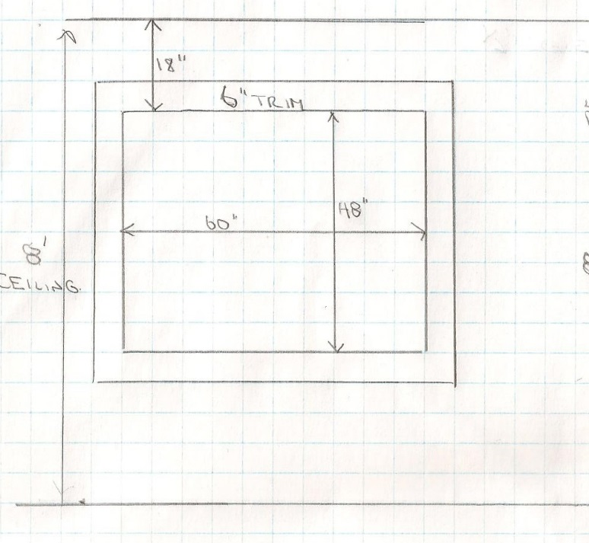

**Part 2 Calculations**:

* This is an operating treatment but we are only covering the window so the treatment when opened will still cover part of the window. When covering the window only you need to add 4” past the trim on each side to cover properly.
* Overlap calculation needs to be added as 4” to the drawing
* Sheers are made fuller than regular fabric at 3X fullness
* When calculating the amount of fabric width needed you need to add all the measurements up across the window as follows in this example from left to right on the drawing
* 4” past trim + 6” trim + 60” window + 4” overlap + 6” trim + 4” past trim = 84”of width needed
* Then calculate the width needed. 84” of space is needed for the treatment and the fullness will be 3X
* 84X3 = 252” + 6 salvage +6 salvage for each panel = 264” of fabric needed
* 264 divide by 36” in a yard = 7.3yards, round up to 7.5 yards (7½ yards)
* Rod width = is the amount of area needed which is calculated previously that showed how much area needs to be covered which is 84”- 4” overlap = 80” rod length.
* Finials will be added to the ends

Length:

* In order to make sure there are no seams in the panels we will railroad the fabric and make the 118” the length. We have turned the fabric on its side to make the width coming off the roll as the length of the sheer panels.
* You will know if you can railroad if the order/purchase length you need is less than 118”.
* Measure from floor to top of trim = 78”
* Add 4” above the trim = 78”+ 4” = 82’= where the rod is hung
* Rings are 2” diameter so must deduct 2” from the drape length (that hangs down from the rod) = 82-2” = 80”
* Want ½ “ from the floor for full length = 79 ½” finished length

By Linda Guthro

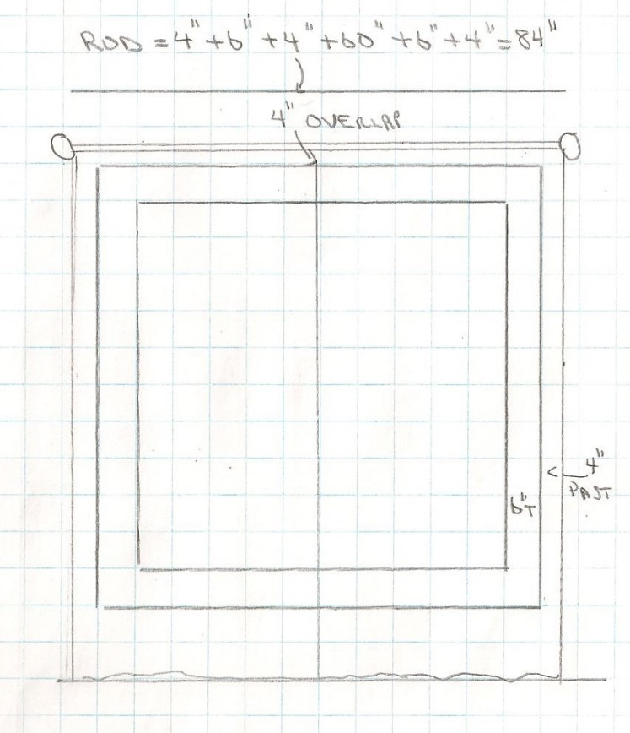

**Part 3 Order dimensions**:

* The finished length is 79 ½” and we need to determine how much fabric is needed for the hem and header (pleat).
* **For all pleated drapery always add 16” for hem and header**.
* So you need to add 79 ½” + 16” = 95 ½” order/purchase length
* Since the fabric was railroaded you will use the width as the length and have plenty of fabric to do this as the length railroaded is 118”
* NOTE: this treatment could be hung higher as long as it does not need more than 118” in order/purchase length.

By Linda Guthro

Drawing shows the width of 118” being railroaded (turned) so that the salvage edges become the top and bottom of the treatment so that there will be no seams in the width.

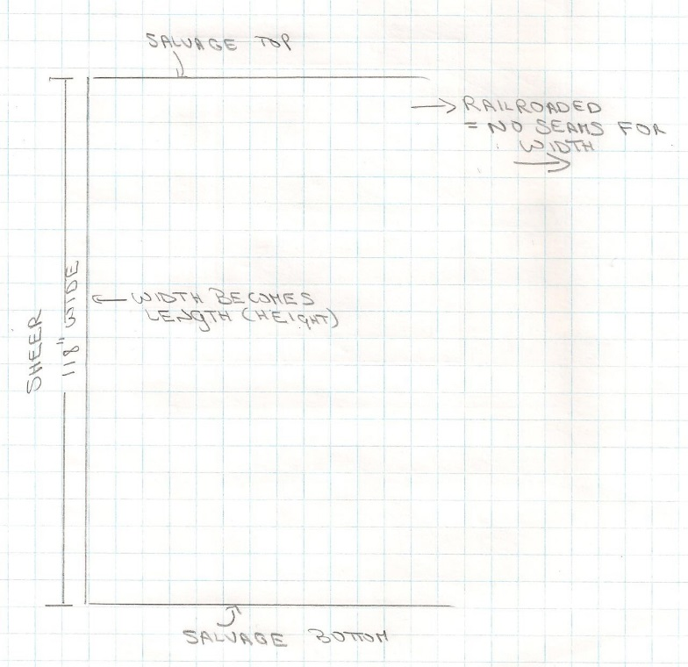

**Things to remember for Sheers:**

Part 1: Measurements of window, trim, walls, ceiling height, kind of treatment (operating or stationary, single or double panel), drawing to scale

Part 2: Is fabric wide enough to railroad (making the width the length), Finished width (# of cuts, salvage, fullness), finished length (how high above window, how long), rod length (window, trim and past window distance)

Part 3: Add hem and header to finished length, pattern repeat if any, round up to nearest ¼ - ½ yard. This is the amount you need to order/purchase to get your desired finished treatment.

**Practice this window example and compare it to the answer.**

* A window that is 48” wide, 72” long + 3” trim added to outside of window
* 8’ ceiling
* Glass is 12” from floor
* Sheer, full length from ceiling to floor to cover window only as one panel hung on I beam
* What yardage is needed? Finished length and width
* What is order/purchase amount
* What is I beam rod length?

**Practice sheer answer**: Can we show this answer after they try it?

**Width:**

* 4” past + 3” trim + 48” + 3” trim + 4” past = 62” x 3 fullness = 186” (no overlap because it is one panel) + 6” selvage (only need 1 because it is one panel)= 192”
* 192 divided by 36 (# of inches in a yard) = 5.3 yards, round up to 5 ½ yards minimum
* **Length:**
* Sheer 118” wide

Railroad fabric:

* 8’ ceiling = 96 – ½ from floor – 1” from ceiling for I beam = 94.5” finished length = enough to railroad making width the length and have no seams in the sheer

**By Linda Guthro**

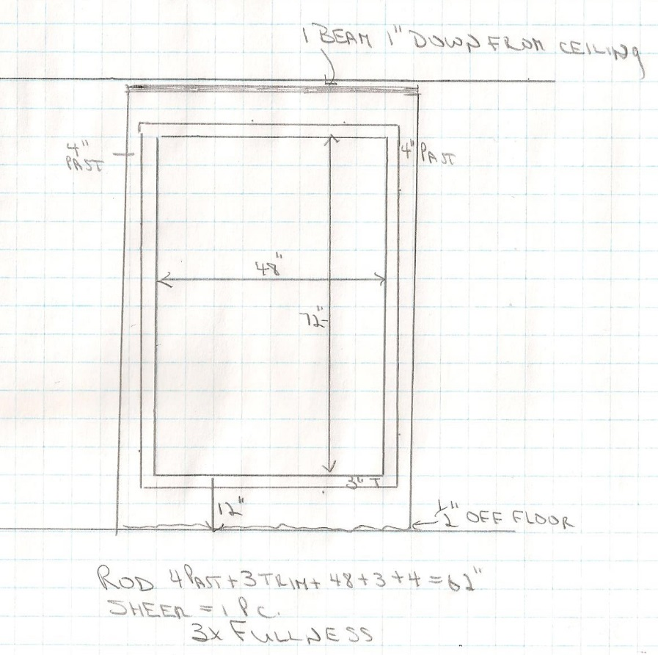

**Rod needed:**

* 4 + 3+ 48 + 3 + 4 = 62” rod (= 5’2” length needed for rod)
* Order 6’ rod and cut to size on install

### Returns:

A return is the distance from the wall to the front of the treatment. In some cases you may want the drape to wrap around the rod and finish at the wall.

If a return is needed add the distance the treatment is out from the wall and add this to your required space needed in step 2.

We will look at this more when learning about valances in another lesson.

Can we redraw this photo to avoid copyright?

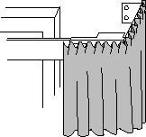

## Conclusion:

This is a lot of information to cover and can seem overwhelming. It is not difficult but you do need to make sure you follow the steps to include all you need in a treatment. Take your time and practice if needed on windows in your own home. Post questions in the discussion forum for this week. Every decorator must pay the same attention to the details no matter how long we have been doing this. It will get easier the more you practice and the more you write down your steps.

********************* End of instructional content *************************

I would like a discussion board this week for lesson discussions and questions.

## Evaluation

Fill out the cells on the right in the table below as appropriate. If the evaluation is one of the following, copy and paste the appropriate table(s) after the evaluation table:

* Discussion
* Quiz or test: Insert one table for each question
* Dropbox

|  |  |
| --- | --- |
| **Evaluation** | |
| What type of assessment will be included? | Discussion  Written Assignment  Test or Quiz  Individual Project  Group Project  Other. Describe: Click here to enter text. |
| When is the assessment due? | last day of the week at 11:55pm |
| How long is the assessment? | 3 pages on graph paper, scanned onto a word document. Included working drawing with measurements, written description showing formula to calculate finished length, order yardage, rod length and if necessary pattern repeat, railroading. |
| What is the weighted value of the assessment? | 10% of final grade |
| List the course learning outcomes for this assessment (number and text). This information must match the Evaluation Matrix. | **CLO04:** Outline current fabric trends including pattern, texture and styles as well as uses and benefits of linings to create quality window treatments for various uses.  **CLO05:** Calculate both hard and soft treatments to custom order from a manufacturer or seamstress based on appropriate measurements to complete a window treatment order for a client |
| How does the assessment connect with the lesson or the overall goals of the course? | This assignment allows the student to put into practice what they have learned this week. It is a good introduction to what they have to do for the rest of the assignments and final project for the semester. |
| Instructions | Use this area to explain:   * what the assignment is * important criteria   FABRIC AND WINDOW TREATMENT  **ASSIGNMENT #2**  **Instructions:**   * On a separate page for each of 3 windows... * Draw a ½” scale drawing of each window in pencil on graph paper as your working copy * On the same page as the drawing…(If using separate page make sure to label the window # on the page * Show the detailed calculations and DESCRIPTION (so your instructor can understand what you are calculating) of how you came to the fabric total * What is the rod width? * How much fabric is needed for this treatment (finished length and order/purchase yardage? * How much lining is needed for this treatment? * Trim is 3”for all assignment(add to the outside of the window measurements)   **Window #1:**   * Ceiling height 10’ * Window size 72” W x 76”L (24” from floor to the bottom of the window glass) * Calculate a pair of stationary pinch pleated side panels ( 1 ½ width) * Fabric has 12” pattern repeat * Hung on decorative rod with 2” rings * Panels cover 4” of glass on each side of window * trouser length on the floor   **Window #2:**   * Ceiling height 8’ * Window size 36”W x 66” L (18”from floor to the bottom of the window glass) * Calculate a pair of grommet style operating drapery that cover this window in a plain fabric 2x fullness that covers the window with no stack back. * Calculate how much fabric and lining you would need to order for this treatment * Hang 4” above the window trim on a metal rod using 1 ½” rings * Floor length (1/2” from floor)   **Window #3:**   * Ceiling height 9’ * Window size 48” W x 60” L (12” from ceiling to top of window glass) * Calculate a single panel of sheers that do NOT operate but are 1 panel. They will cover the window with no stack back. * Sheers are 3x fullness and determine if the fabric can be railroaded * Hang 6” above the window frame and finish ½ “ from the floor * Calculate how much fabric you would need to order for this treatment   **Scan and post your assignment as 1 document and place in the drop box provided**  **HAVE FUN!!** |
| Rubric or Marking Scheme | Use this area to explain how the assignment will be assessed or indicate the file name for the rubric.  Click here to enter text.   |  |  |  |  |  |  | | --- | --- | --- | --- | --- | --- | | **Rubrics:** |  |  |  |  |  | | **#2 Assignment** | **Distinguished** | **Good** | **Acceptable** | **Developing** | **Needs work** | | **Working copy drawing (accuracy, ½” scale, dimensions showing, outline of treatment, rod)** | Displays an excellent understanding of the scale, dimensions, measurements and rod height and length | Displays a solid understanding of the scale, dimensions, measurements and rod height and length | Some understanding of the scale, dimensions, measurements and rod height and length | Displays limited understanding of the scale dimensions, measurements and rod height and length | Displays little understanding of the scale dimensions, measurements and rod height and length | |  | 5 points | 4 – 7.75 points | 3 - 3.75 points | 2 – 2.75 points | 0 – 1.75 points | | **Critical Thinking and accuracy of calculations** | Clear evidence of critical thinking. Assignment is characterized by clarity of calculations showing correct finished length, order/purchase yardage, rod length and where necessary the pattern repeat, pleat style, railroading | Evidence of critical thinking. Assignment is characterized by clarity of calculations showing correct finished length, order/purchase yardage, rod length and where necessary the pattern repeat, pleat style, railroading | Some evidence of critical thinking. Argument is sometimes clear but lacking some clarity of calculations showing with one error in any of the finished length, order/purchase yardage, rod length and where necessary the pattern repeat, pleat style, railroading | Beginnings of critical thinking; however, assignment tends to not explain meanings of calculations with 2 or more errors in any of the finished length, order/purchase yardage, rod length and where necessary the pattern repeat, pleat style, railroading | Critical thinking not evident. Incorrect calculations and multiple errors in any of the finished length, order/purchase yardage, rod length and where necessary the pattern repeat, pleat style, railroading | |  | 5 points | 4 – 4.75 points | 3- 3.75 points | 2 – 2.75 points | 0 - 1.75 points | | **Communicates clearly** | Assignment is clear and easy to read with no spelling or grammar error | Assignment is clear with some spelling or grammatical errors | Assignment requires concentration to read owing to spelling or grammatical errors | Assignment is difficult to read owing to organization, spelling and or grammatical errors | Assignment is very difficult to read owing to errors in organization, spelling and or grammar | |  | 5 points | 4 – 4.75 points | 3 - 3.75 points | 2 – 2.75 points | 0 – 1.75 points | | **Overall Score** | Distinguished  15 points | Good  12 or more points | Acceptable  9 or more points | Developing  5 or more points | Needs work  O or more points | |